WEEK 2 – Provider-Agnostic LLM Client

Manaswi – 2520030411
Step-01: Download Ollama

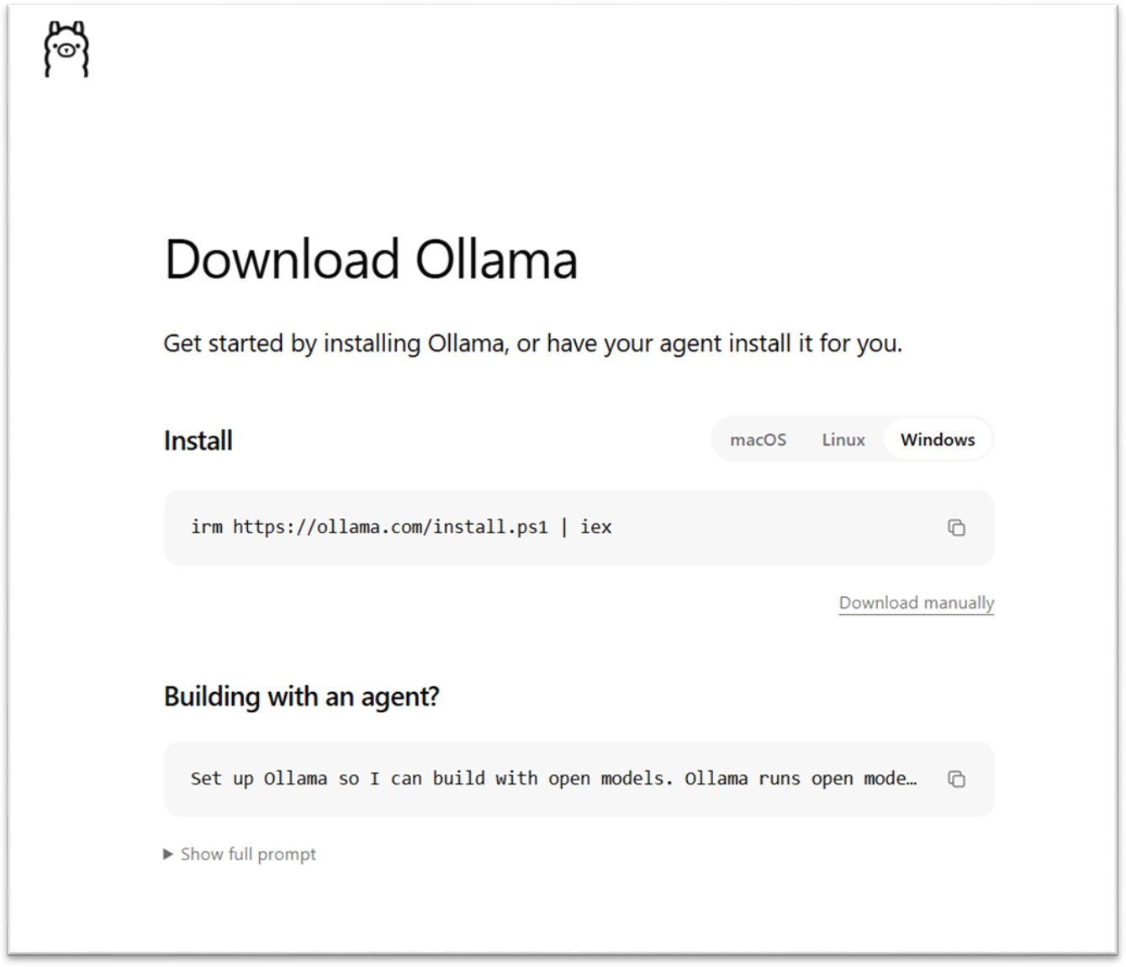

Step-02: Verify Ollama Installation

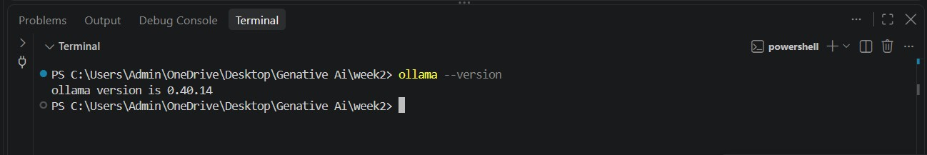
Step-04: Download Llama 3.2 Model
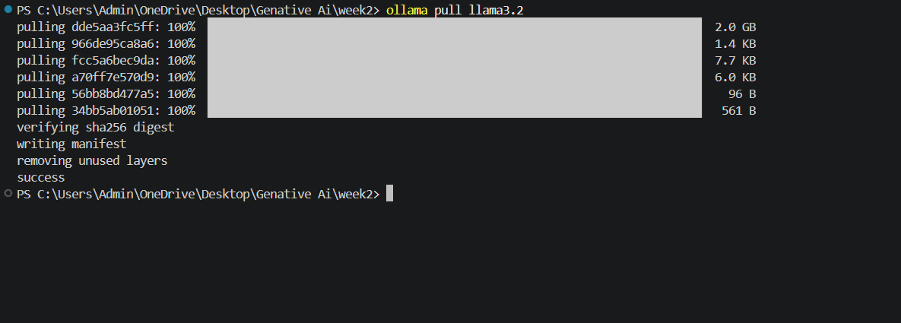
Step-05: Create Week-2 Project Files

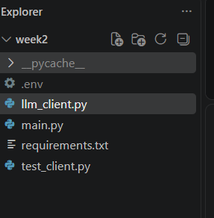
Step-06: Implement LLM Client

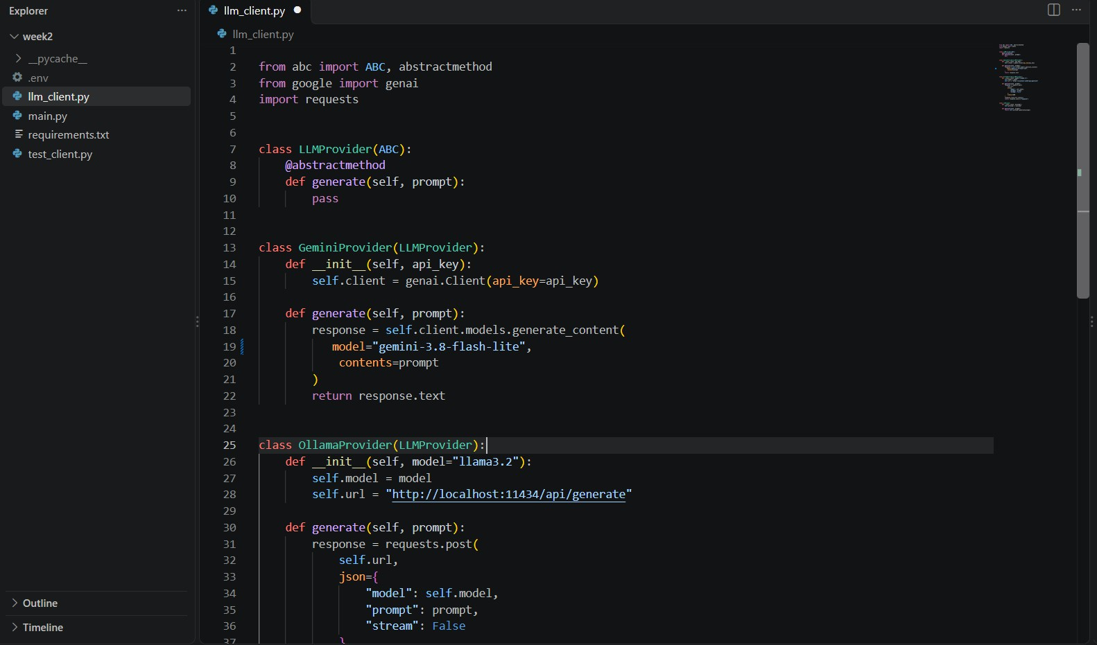

Step-07: Implement main.py Program

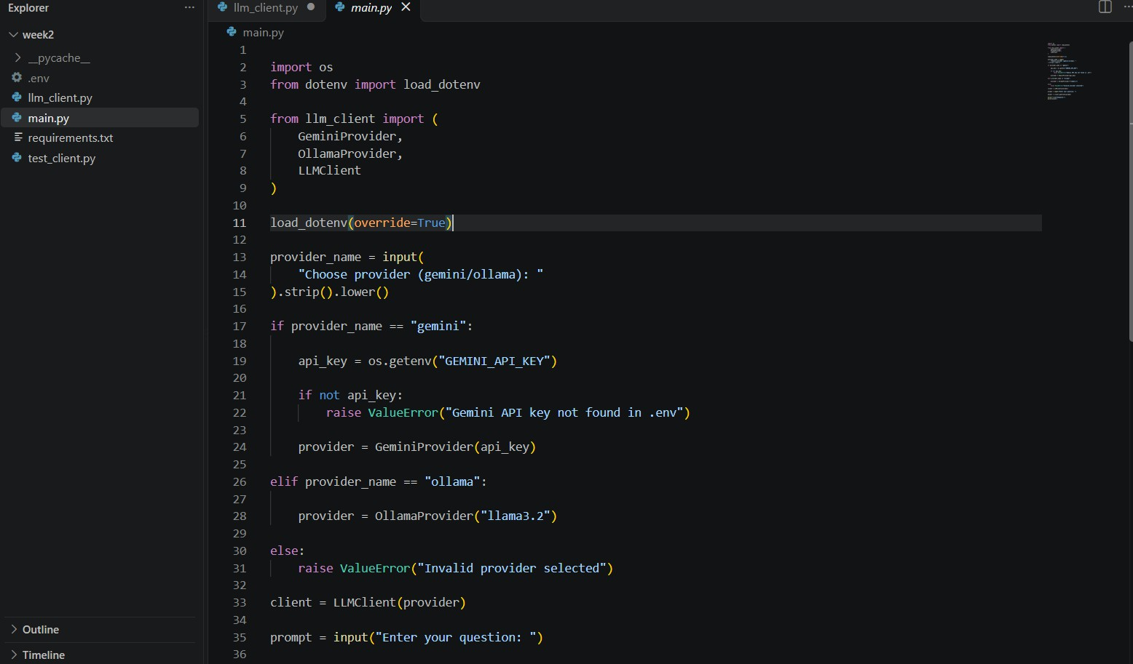

Step-08: Implement test_client.py

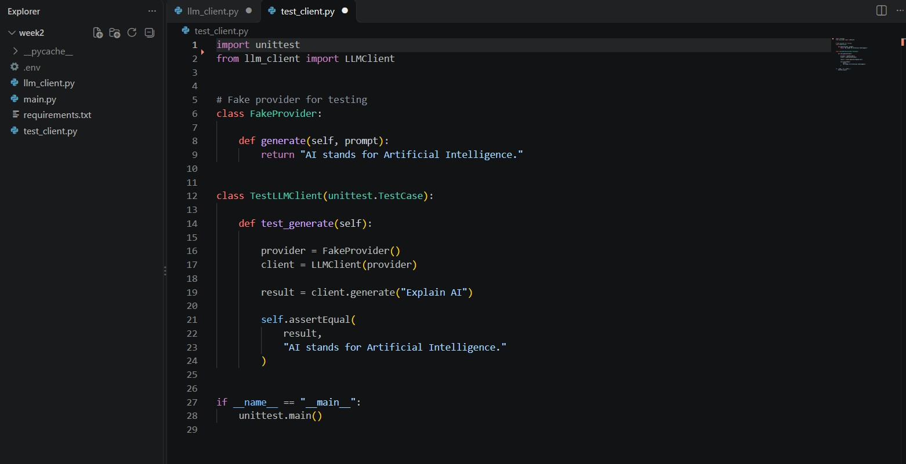

Step-09: Install Dependencies

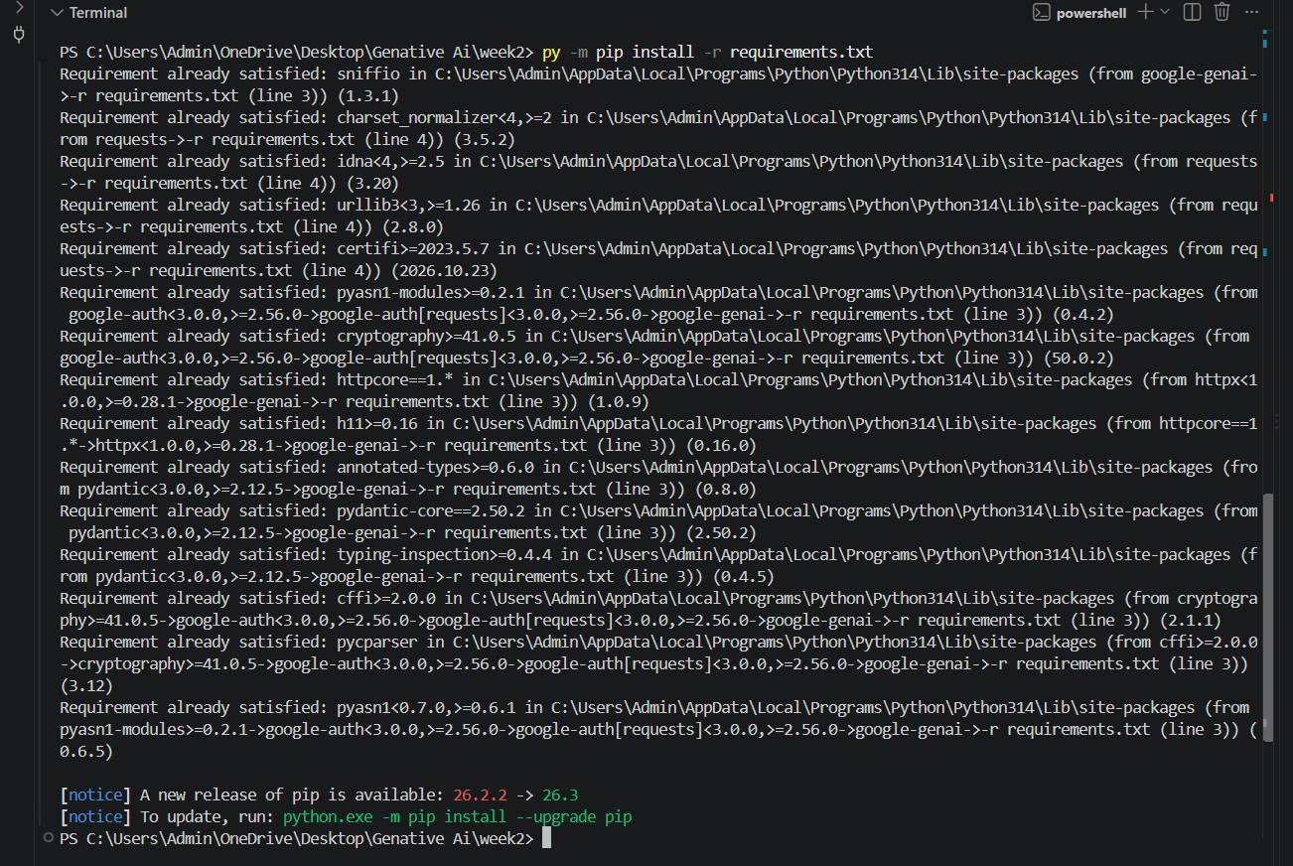
Step-10: Execute and Test the Application Using OLLAMA:

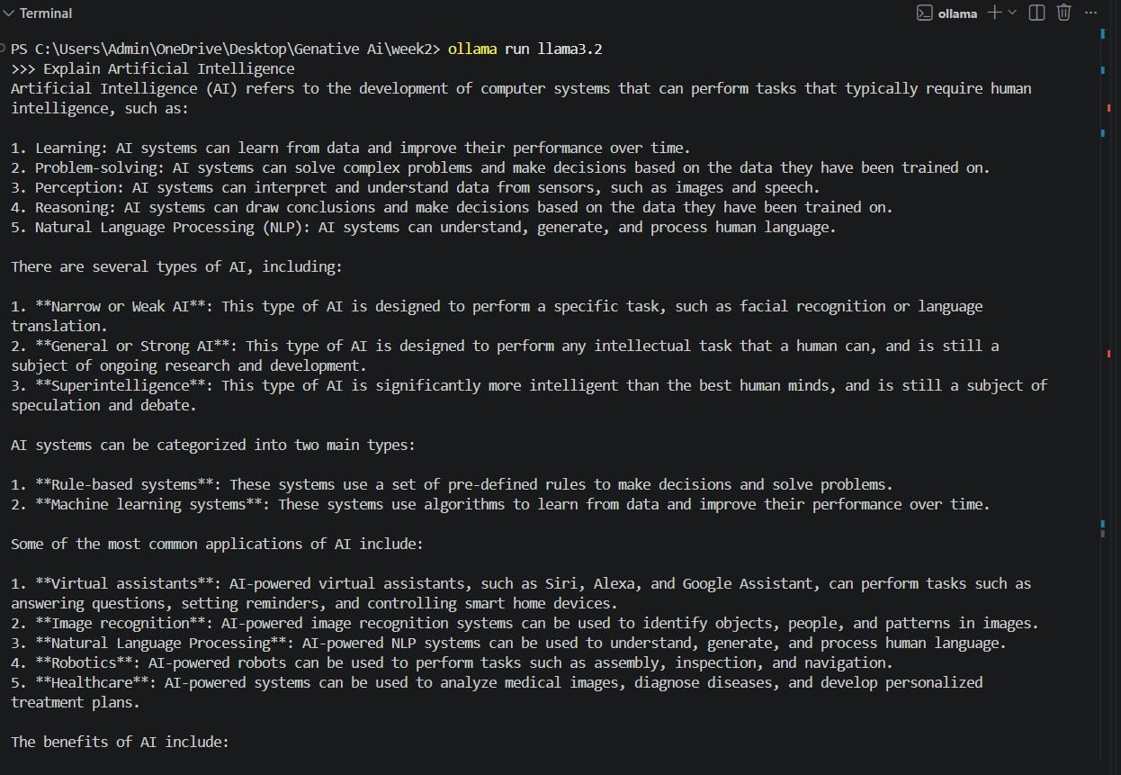
Using GEMINI:

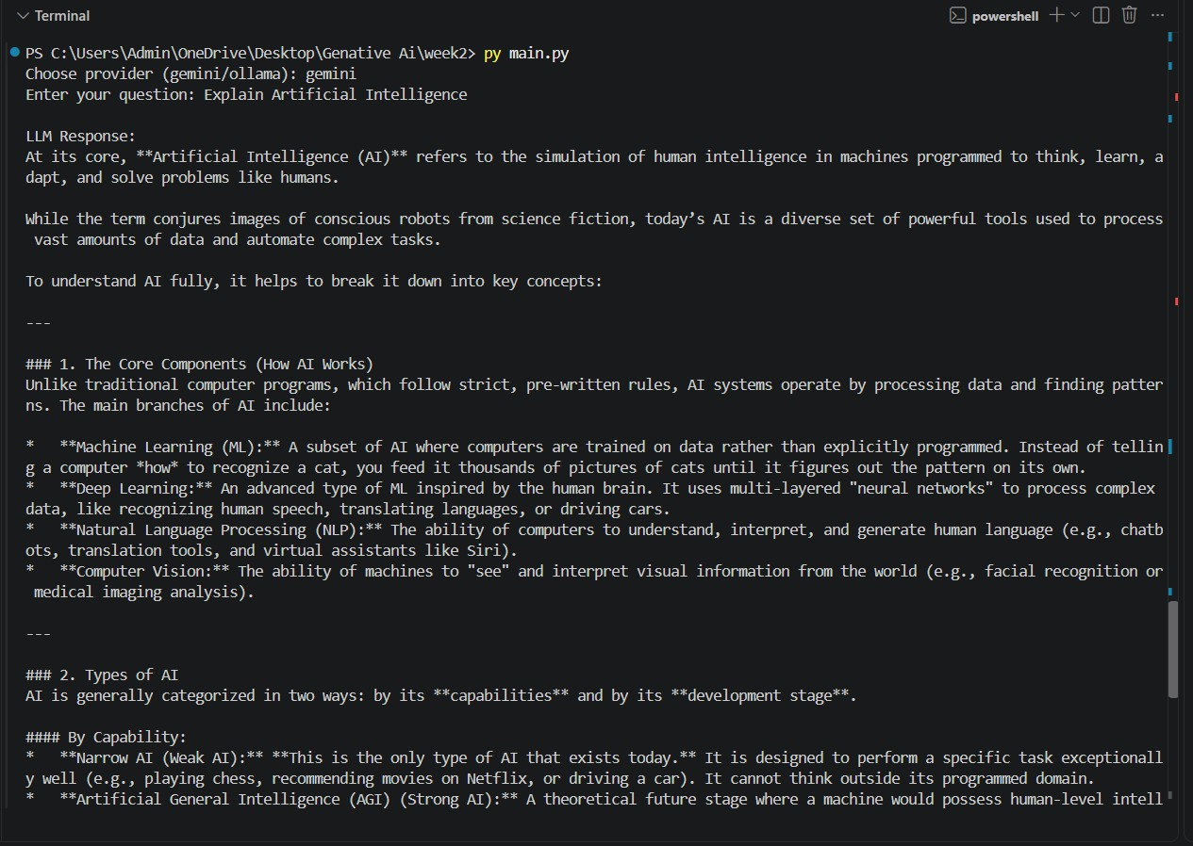
Step-11: Uploading Project:
[Successfully uploaded project into github.]

